Technical Project Charter: Lewis Retail Engine - Integration & Revenue Audit
Project Phase: Retail Systems & Transactional Integrity
Team members: Sachin Kirsten Brown and Moegamat Yousha diedericks
2026
Project Phase: Retail Systems & Transactional Integrity
Sprint Duration: 30 Days
Team Structure: 3-Person Quality Engineering Squad
Target Systems: Lewis Retail API (Node.js), Lewis SQL Database

Task 3: Database Integrity & "Systems of Record" Audit (SQL)
Requirement:
50+ Audit Queries. Each query must be saved as an independent .sql file in the Database/sql-queries/ directory.
3.1 Stock Reconciliation (15 Queries):
Identify "Stock Mismatches"—instances where the API reported an available quantity that does not match the sum of physical stock in the Inventory table.

Stock vs Orders (Main Audit)
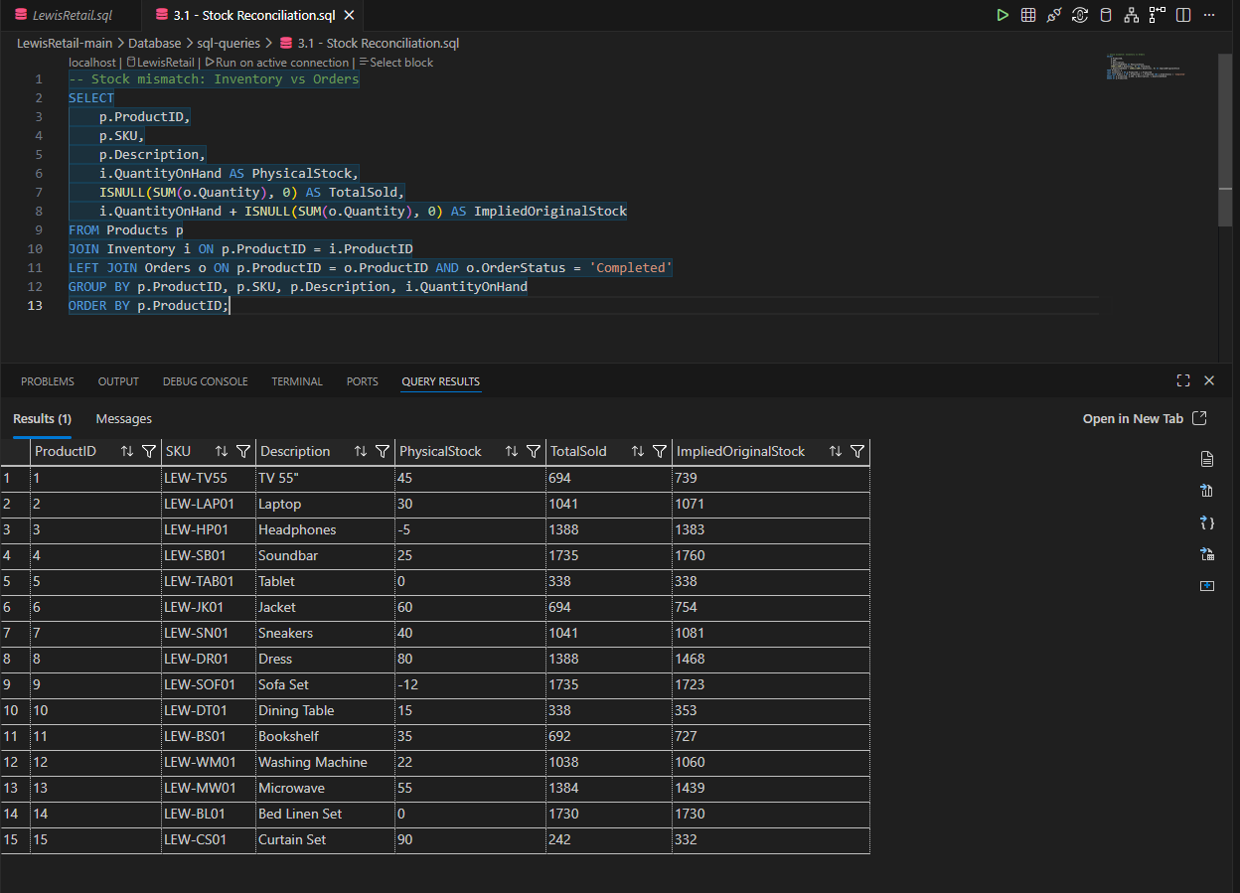

Query 1 – All Stock
SELECT *
FROM Inventory
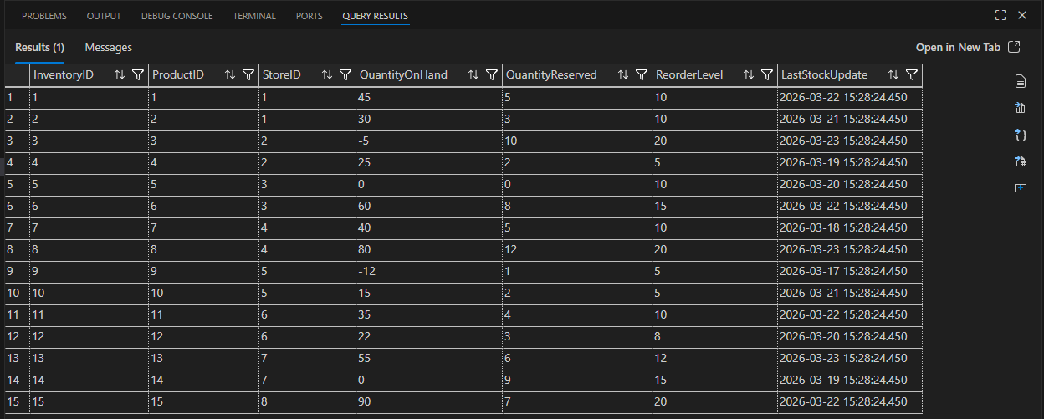

Query 2 - Negative Stock
SELECT *
FROM Inventory
WHERE QuantityOnHand < 0;
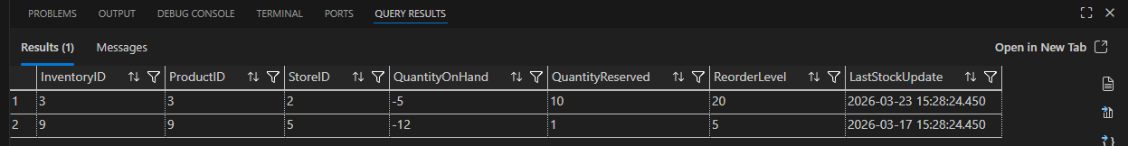

Query 3 - Zero Stock
SELECT *
FROM Inventory
WHERE QuantityOnHand = 0;
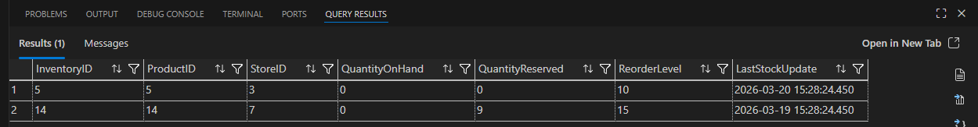

Query 4 - Reserved > Available
SELECT *
FROM Inventory
WHERE QuantityReserved > QuantityOnHand;
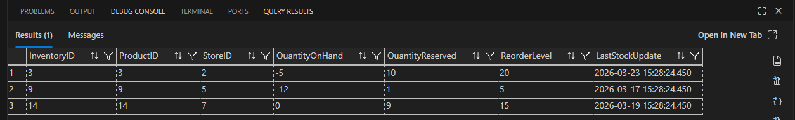

Query 5 - Orders Greater Than Stock
SELECT
p.ProductID,
SUM(o.Quantity) AS TotalSold,
SUM(i.QuantityOnHand) AS Stock
FROM Products p
JOIN Inventory i ON p.ProductID = i.ProductID
JOIN Orders o ON p.ProductID = o.ProductID
GROUP BY p.ProductID
HAVING SUM(o.Quantity) > SUM(i.QuantityOnHand);
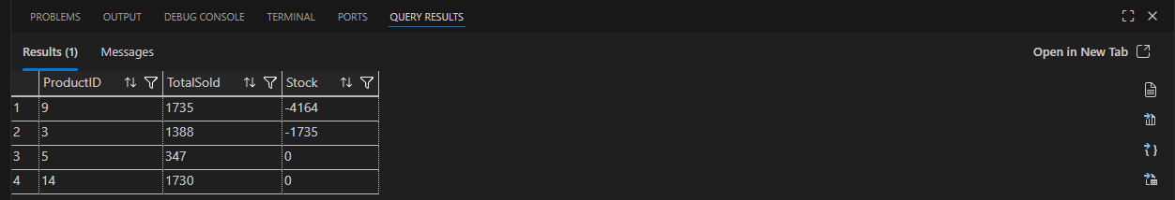

Query 6 - Products Never Sold
SELECT p.ProductID, p.Description
FROM Products p
LEFT JOIN Orders o ON p.ProductID = o.ProductID
WHERE o.ProductID IS NULL;
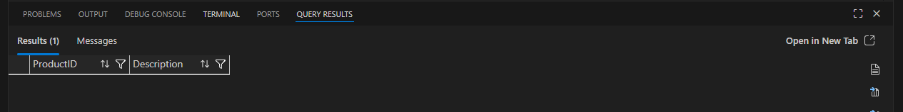

Query 7 – Stock Without Orders
SELECT *
FROM Inventory i
LEFT JOIN Orders o ON i.ProductID = o.ProductID
WHERE o.ProductID IS NULL;
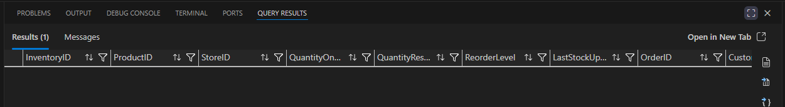

Query 8 - Orders Without Inventory
SELECT *
FROM Orders o
LEFT JOIN Inventory i ON o.ProductID = i.ProductID
WHERE i.ProductID IS NULL;

Query 9 - Total Stock Per Product
SELECT
ProductID,
SUM(QuantityOnHand) AS TotalStock
FROM Inventory
GROUP BY ProductID;
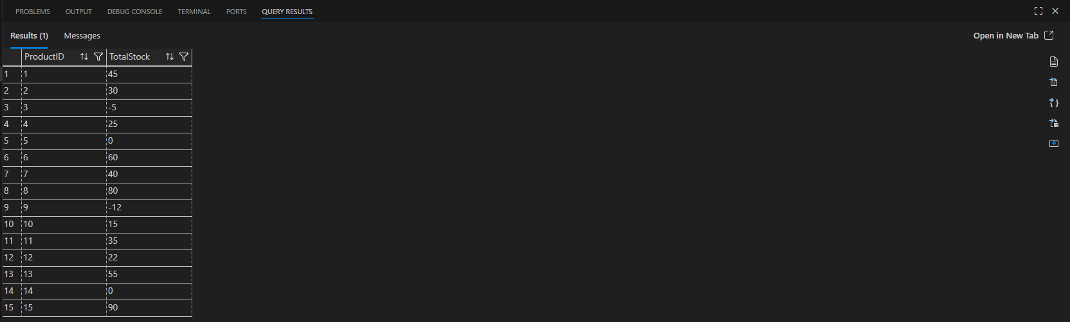

Query 10 - Duplicate Inventory Records
SELECT ProductID, COUNT(*)
FROM Inventory
GROUP BY ProductID
HAVING COUNT(*) > 1;

Query 11 - High Stock Low Sales
SELECT
p.ProductID,
SUM(i.QuantityOnHand) AS Stock,
ISNULL(SUM(o.Quantity),0) AS Sold
FROM Products p
JOIN Inventory i ON p.ProductID = i.ProductID
LEFT JOIN Orders o ON p.ProductID = o.ProductID
GROUP BY p.ProductID
HAVING SUM(i.QuantityOnHand) > 100 AND ISNULL(SUM(o.Quantity),0) < 10;
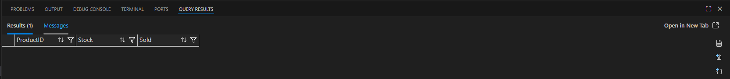

Query 12 - Low Stock High Sales
SELECT
p.ProductID,
SUM(i.QuantityOnHand) AS Stock,
SUM(o.Quantity) AS Sold
FROM Products p
JOIN Inventory i ON p.ProductID = i.ProductID
JOIN Orders o ON p.ProductID = o.ProductID
GROUP BY p.ProductID
HAVING SUM(i.QuantityOnHand) < 10 AND SUM(o.Quantity) > 100;
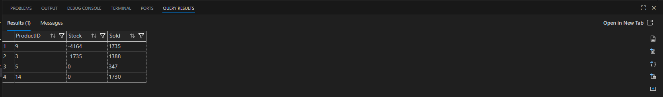

Query 13 - Inventory with NULL Values
SELECT *
FROM Inventory
WHERE QuantityOnHand IS NULL;
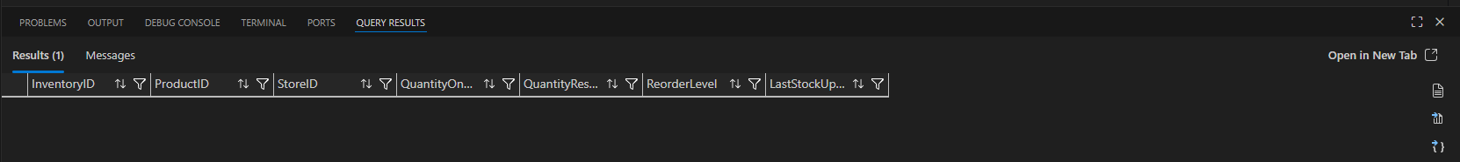

Query 14 - Inactive Products with Stock
SELECT *
FROM Products p
JOIN Inventory i ON p.ProductID = i.ProductID
WHERE p.IsActive = 0 AND i.QuantityOnHand > 0;
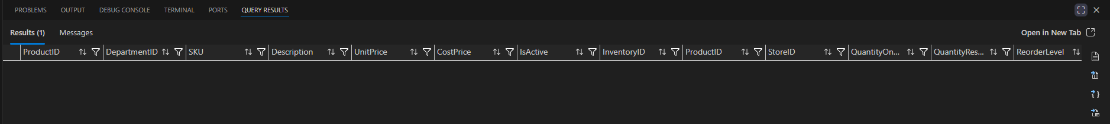

Query 15 - Mismatch Between Locations
SELECT
ProductID,
COUNT(DISTINCT StoreID) AS StoreCount,
SUM(QuantityOnHand) AS TotalStock
FROM Inventory
GROUP BY ProductID
HAVING COUNT(DISTINCT StoreID) > 1;
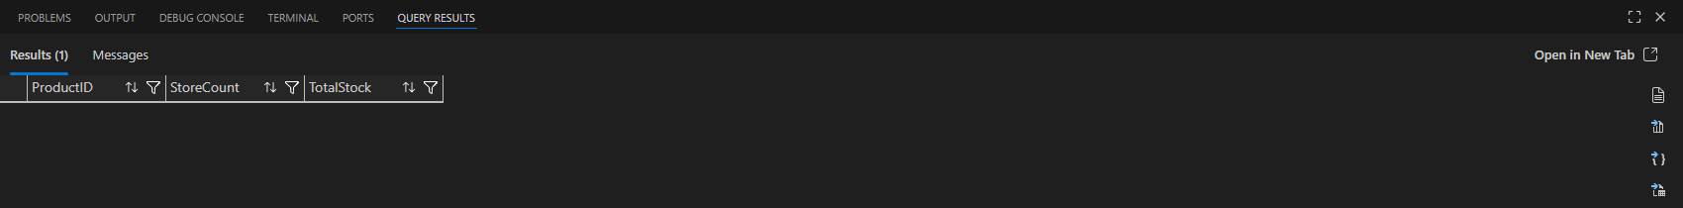

Questions to answer:
Does the QuantityOnHand reconcile with total orders processed?
- No, the QuantityOnHand does not always reconcile with the total orders processed. Several queries show discrepancies where the total quantity sold exceeds the available inventory or where the implied original stock does not align with expected values. This indicates inconsistencies between recorded sales transactions and physical stock levels.
Are there products where inventory shows a different quantity than what the order history implies?
- Yes, there are products where the inventory does not match the order history. The stock reconciliation query shows differences between physical stock and calculated stock based on completed orders. This suggests issues such as missing transactions, incorrect stock updates, or data synchronization failures between systems.
Are there any negative stock values? What does this mean?
- Yes, negative stock values are present in the Inventory table. This indicates that more items have been sold than are available in stock. This is a critical data integrity issue and may be caused by delayed stock updates, system errors, or lack of validation controls. Negative stock can lead to overselling and financial discrepancies in the retail system.

3.2 Pricing Audit (15 Queries):
Perform a multi-table JOIN across Products, Orders, and VAT_Rates. Verify if the retail engine applied the exact VAT and discount rules for the most recent 1,000 sales records.

Orders vs Calculated Total (MAIN QUERY)
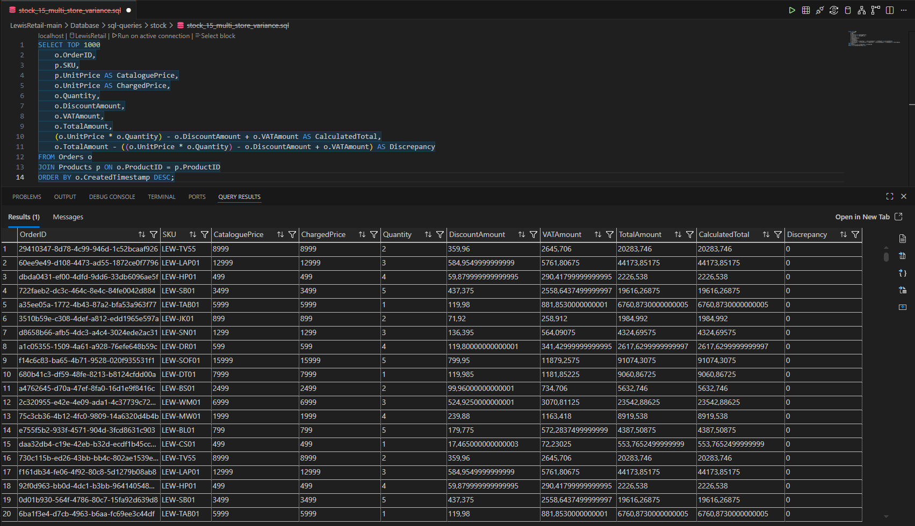

Query 1 – Top 10 Unit Prices
SELECT TOP 10 UnitPrice
from Orders
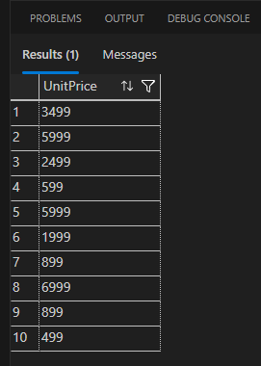

Query 2 – Records with Incorrect Totals
SELECT *
FROM Orders
WHERE TotalAmount <> (UnitPrice * Quantity - DiscountAmount + VATAmount);
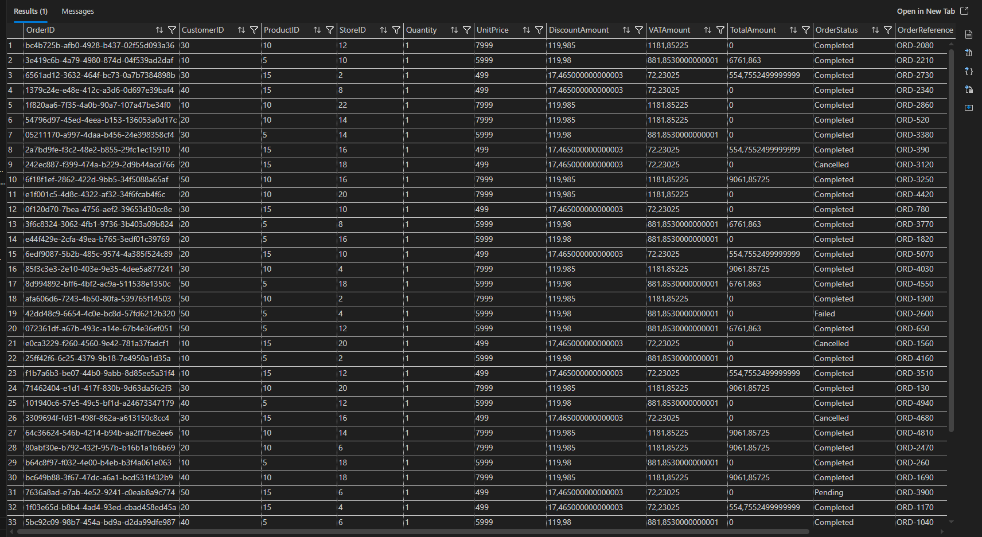

Query 3 – Total Financial Discrepancy
SELECT
SUM(TotalAmount - ((UnitPrice * Quantity) - DiscountAmount + VATAmount)) AS TotalDiscrepancy
FROM Orders;
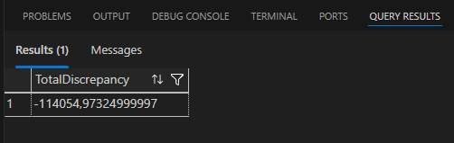

Query 4 – Orders with Zero Total (Revenue Loss)
SELECT OrderID, CustomerID, TotalAmount, CreatedTimestamp, OrderStatus, VATAmount, UnitPrice, DiscountAmount
FROM Orders
WHERE TotalAmount = 0;
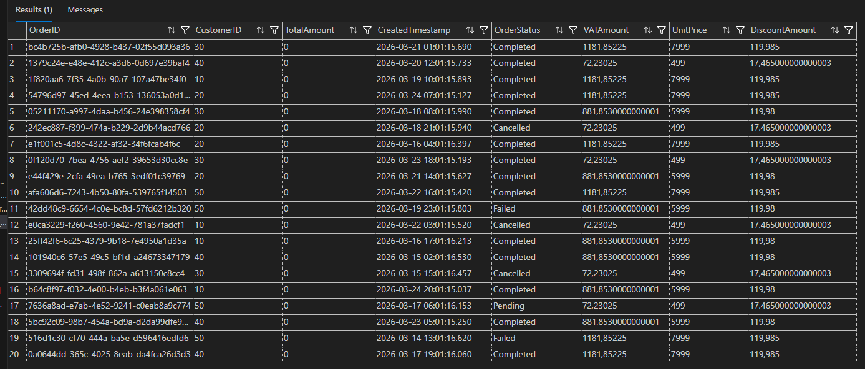

Query 5 – Negative Totals
SELECT *
FROM Orders
WHERE TotalAmount < 0;
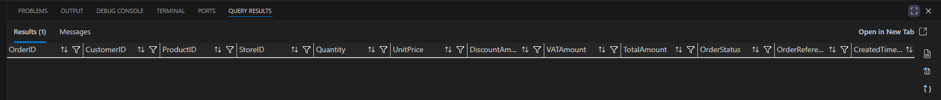

Query 6 – VAT Calculation Check (15%)
SELECT
OrderID,
VATAmount,
(UnitPrice * Quantity - DiscountAmount) * 0.15 AS ExpectedVAT
FROM Orders
WHERE VATAmount <> (UnitPrice * Quantity - DiscountAmount) * 0.15;
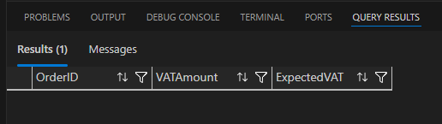

Query 7 – Discount Greater Than Price
SELECT *
FROM Orders
WHERE DiscountAmount > (UnitPrice * Quantity);

Query 8 – Missing VAT Values
SELECT *
FROM Orders
WHERE VATAmount IS NULL;
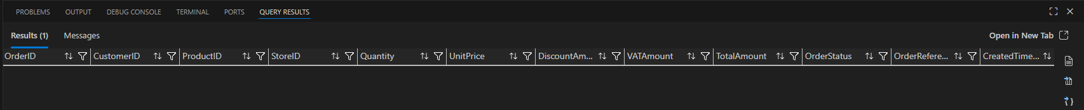

Query 9 – Missing Discount Values
SELECT *
FROM Orders
WHERE DiscountAmount IS NULL;

Query 10 – Charged Price vs Catalogue Price
SELECT
o.OrderID,
p.UnitPrice AS CataloguePrice,
o.UnitPrice AS ChargedPrice
FROM Orders o
JOIN Products p ON o.ProductID = p.ProductID
WHERE o.UnitPrice <> p.UnitPrice;
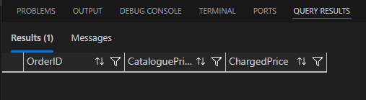

Query 11 – High Discrepancy Orders
SELECT *
FROM Orders
WHERE ABS(TotalAmount - ((UnitPrice * Quantity) - DiscountAmount + VATAmount)) > 1;
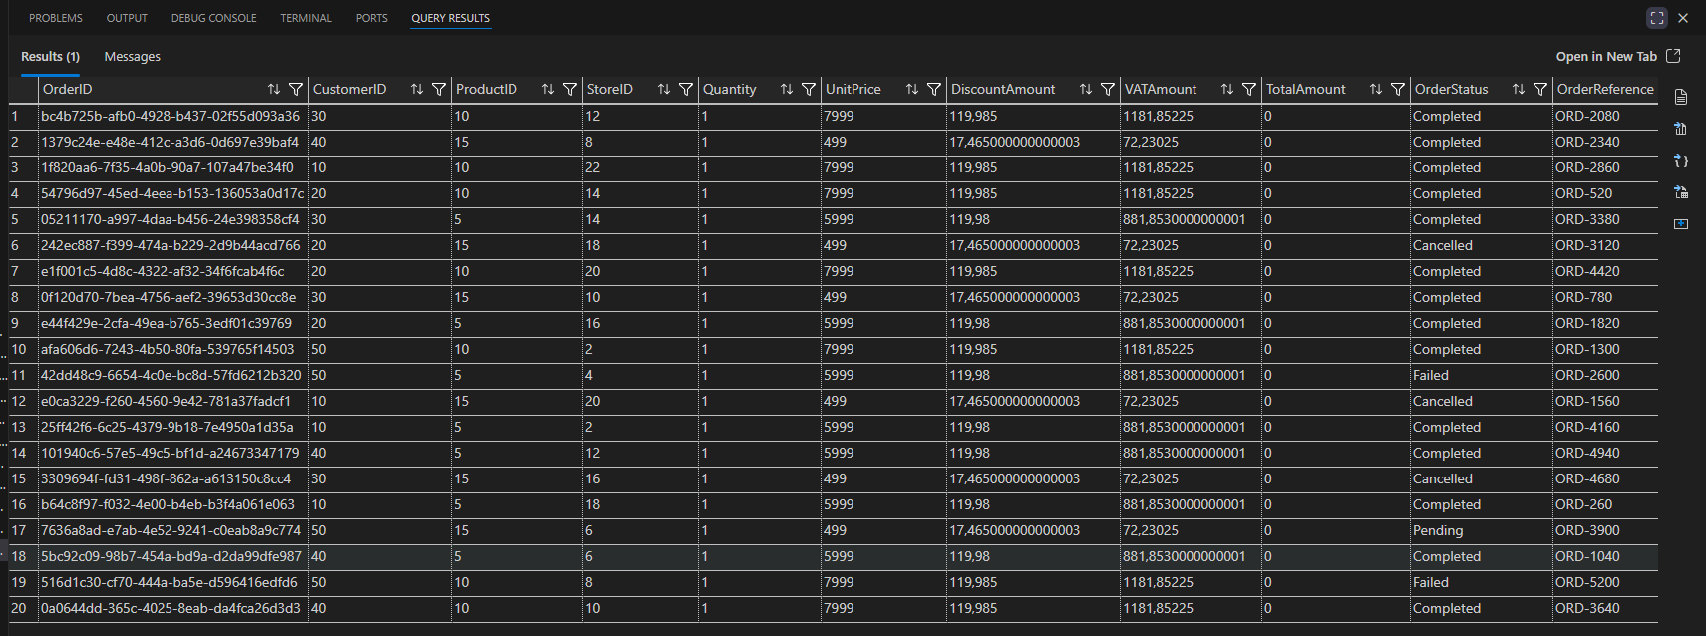

Query 12 – Recent 1000 Orders Only
SELECT TOP 1000 *
FROM Orders
ORDER BY CreatedTimestamp DESC;
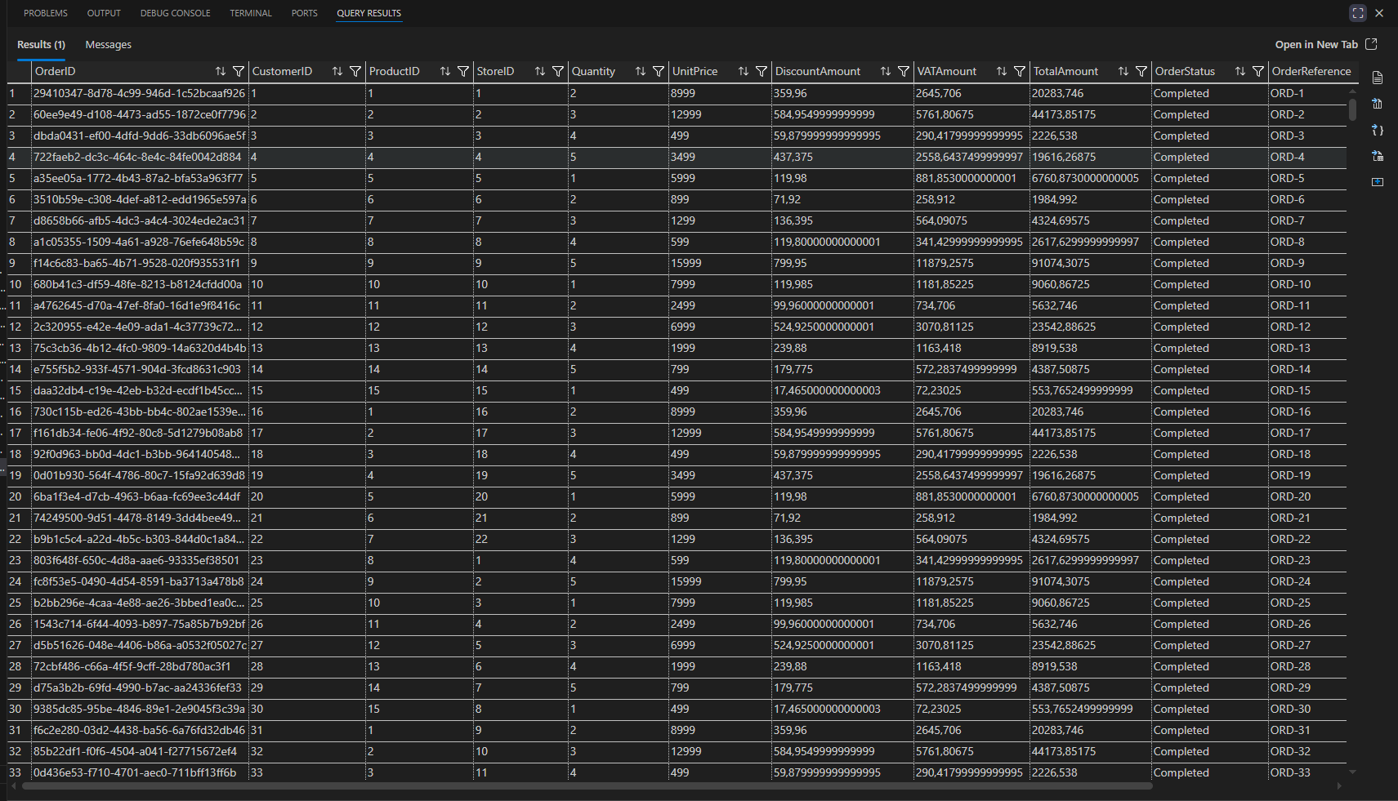

Query 13 – Average Discrepancy
SELECT
AVG(TotalAmount - ((UnitPrice * Quantity) - DiscountAmount + VATAmount)) AS AvgDiscrepancy
FROM Orders;
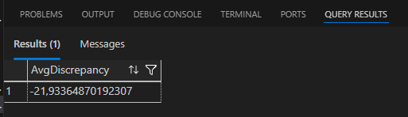

Query 14 – Orders with No Discount Applied
SELECT *
FROM Orders
WHERE DiscountAmount = 0;

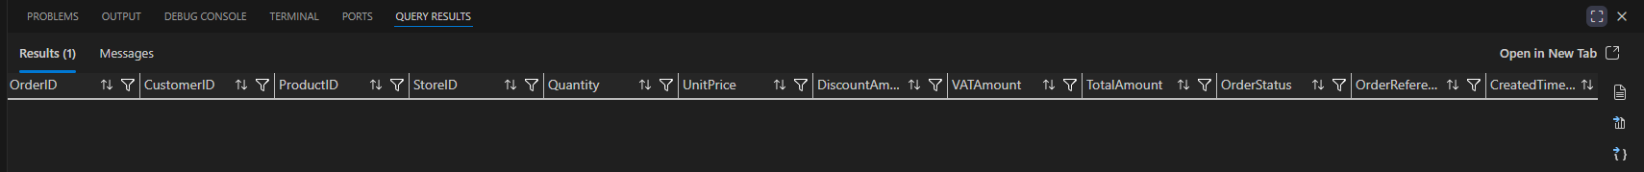

Query 15 - VAT + Discount Impact Summary
SELECT
SUM(UnitPrice * Quantity) AS GrossSales,
SUM(DiscountAmount) AS TotalDiscount,
SUM(VATAmount) AS TotalVAT,
SUM(TotalAmount) AS NetSales
FROM Orders;
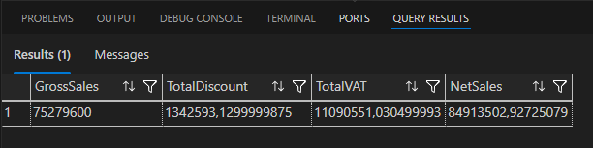

Are there records where TotalAmount does not match the calculated total?
- Yes, there are multiple records where the TotalAmount does not match the calculated total. The pricing validation queries reveal discrepancies between the stored total and the expected total derived from unit price, quantity, discount, and VAT. This indicates inconsistencies in how pricing rules were applied during transaction processing.

What is the financial impact of the discrepancies across all records?
- The financial impact is measurable by summing all discrepancies across the dataset. The total discrepancy query shows that even small rounding or calculation errors accumulate over thousands of transactions, resulting in a significant overall financial variance. This can lead to inaccurate revenue reporting, potential financial losses, and audit compliance risks in a retail environment.

Which data type is causing precision loss?
- The FLOAT data type is responsible for precision loss. FLOAT stores approximate numeric values, which can introduce rounding errors during calculations involving VAT and discounts. These small inaccuracies become significant when aggregated across high-volume transactions. To prevent this, monetary values should be stored using precise data types such as DECIMAL(10,2).

3.3 Data Hygiene & Constraints (10 Queries):
Identify data integrity flaws, such as duplicate SKU codes, negative price values, or customer records with invalid contact formatting.
Query 1 - Duplicate SKU Codes
SELECT SKU, COUNT(*) AS Occurrences
FROM Products
GROUP BY SKU
HAVING COUNT(*) > 1;
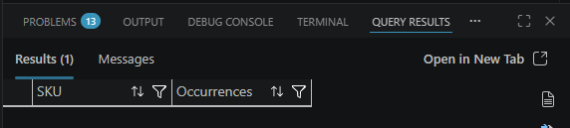

Query 2 - Negative Prices
SELECT ProductID, SKU, UnitPrice, CostPrice
FROM Products
WHERE UnitPrice < 0 OR CostPrice < 0;
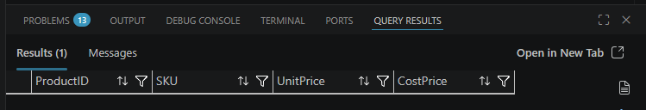

Query 3 - Zero Prices
SELECT *
FROM Products
WHERE UnitPrice = 0 OR CostPrice = 0;
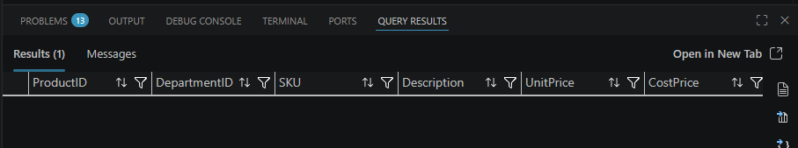

Query 4 - Invalid Customer Phone Numbers
SELECT CustomerID, FullName, Phone
FROM Customers
WHERE LEN(Phone) < 10
OR LEN(Phone) > 12
OR Phone LIKE '%[^0-9]%';
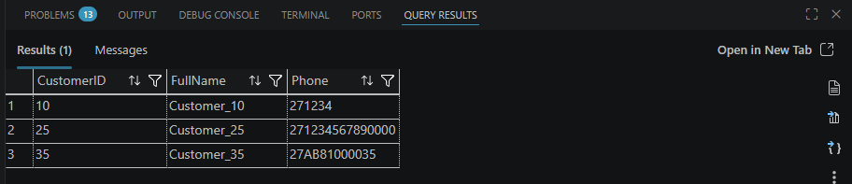

Query 5 - NULL Customer Phone Numbers
SELECT *
FROM Customers
WHERE Phone IS NULL;
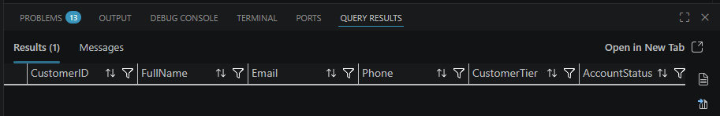

Query 6 - Duplicate Order References
SELECT OrderReference, COUNT(*) AS Occurrences
FROM Orders
GROUP BY OrderReference
HAVING COUNT(*) > 1;
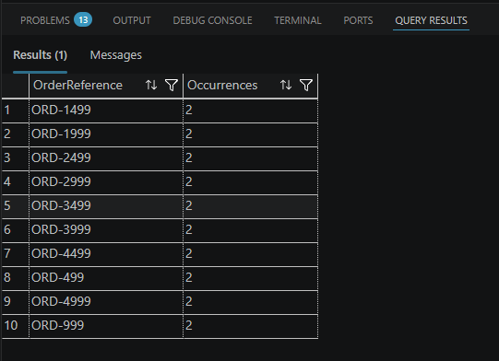

Query 7 - Orders with NULL ProductID
SELECT *
FROM Orders
WHERE ProductID IS NULL;
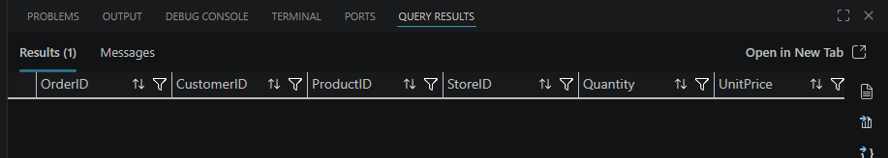

Query 8 - Products with NULL SKU
SELECT *
FROM Products
WHERE SKU IS NULL;
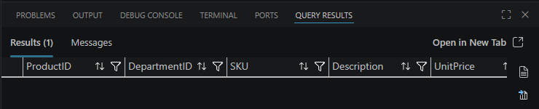

Query 9 - Customers with Missing Names
SELECT *
FROM Customers
WHERE FullName IS NULL OR FullName = '';
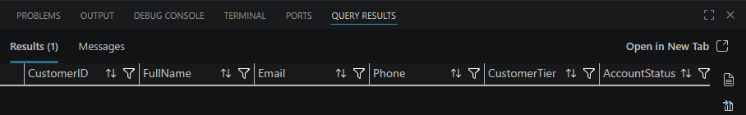

Query 10 - Invalid Email Format
SELECT *
FROM Customers
WHERE Email NOT LIKE '%@%.%';
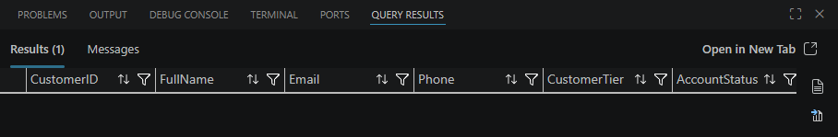

1. Are there any duplicate SKU codes?
Yes, duplicate SKU codes exist in the Products table. The duplicate SKU query identifies multiple records sharing the same SKU, which violates the uniqueness constraint expected for product identification. This can lead to confusion in inventory tracking, pricing, and reporting.

2. Are there products with negative or zero prices?
Yes, there are products with negative and zero prices. Negative prices indicate serious data entry or system errors, while zero prices may indicate missing pricing data or promotional items incorrectly configured. Both cases can result in revenue loss and inaccurate financial reporting.

3. Are there customers with invalid phone numbers?
Yes, there are customers with invalid phone numbers. The validation query shows phone numbers that are either too short, too long, or contain non-numeric characters. This affects communication reliability and indicates poor data validation controls at the point of data entry.

4. Are there duplicate order references?
Yes, duplicate order references are present in the Orders table. This suggests that the system may be allowing duplicate transaction entries or failing to enforce unique constraints. This can lead to duplicate billing, reporting errors, and audit failures.

3.4 Business Intelligence Reporting (10 Queries):
Generate executive reports identifying "Highest Revenue SKUs" and "Slow-Moving Stock" to assist retail buyers in strategic stock management.
Query 1 - Highest Revenue SKUs
SELECT
p.SKU,
p.Description,
d.DepartmentName,
COUNT(o.OrderID) AS TimesSold,
SUM(o.TotalAmount) AS TotalRevenue
FROM Products p
JOIN Departments d ON p.DepartmentID = d.DepartmentID
LEFT JOIN Orders o ON p.ProductID = o.ProductID AND o.OrderStatus = 'Completed'
GROUP BY p.SKU, p.Description, d.DepartmentName
ORDER BY TotalRevenue DESC;
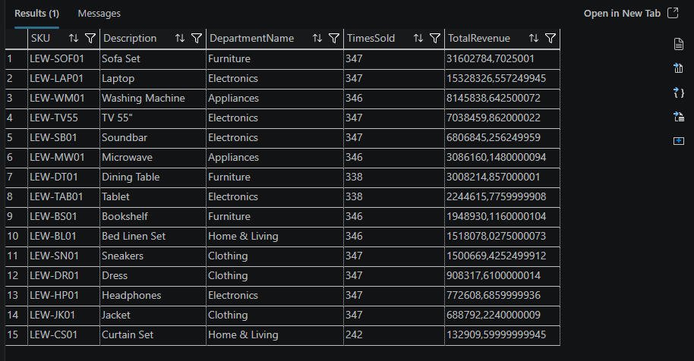

Query 2 - Top 10 Revenue Products
SELECT TOP 10
p.SKU,
p.Description,
SUM(o.TotalAmount) AS TotalRevenue
FROM Products p
JOIN Orders o ON p.ProductID = o.ProductID
GROUP BY p.SKU, p.Description
ORDER BY TotalRevenue DESC;
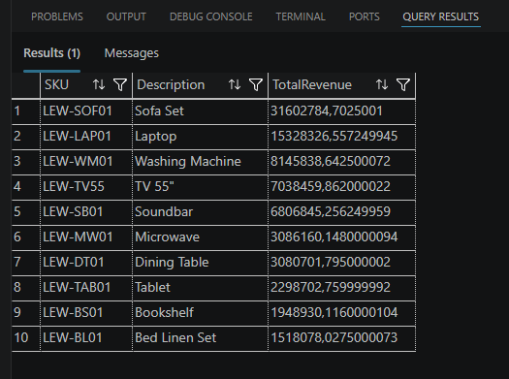

Query 3 - Slow-Moving Stock
SELECT
p.SKU,
p.Description,
i.QuantityOnHand,
COUNT(o.OrderID) AS TimesOrdered
FROM Products p
JOIN Inventory i ON p.ProductID = i.ProductID
LEFT JOIN Orders o ON p.ProductID = o.ProductID
GROUP BY p.SKU, p.Description, i.QuantityOnHand
ORDER BY TimesOrdered ASC;
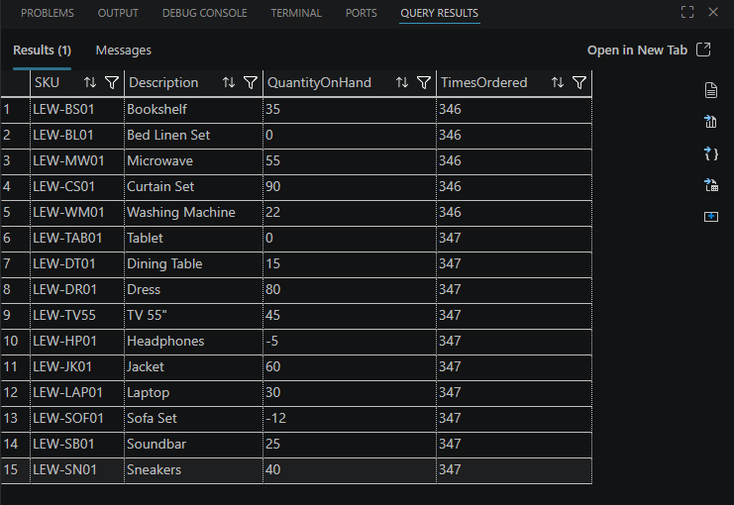

Query 4 - Dead Stock (Never Sold)
SELECT
p.SKU,
p.Description,
i.QuantityOnHand
FROM Products p
JOIN Inventory i ON p.ProductID = i.ProductID
LEFT JOIN Orders o ON p.ProductID = o.ProductID
WHERE o.OrderID IS NULL;
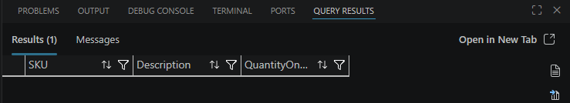

Query 5 - Revenue by Department
SELECT
d.DepartmentName,
SUM(o.TotalAmount) AS DepartmentRevenue
FROM Departments d
JOIN Products p ON d.DepartmentID = p.DepartmentID
JOIN Orders o ON p.ProductID = o.ProductID
GROUP BY d.DepartmentName
ORDER BY DepartmentRevenue DESC;
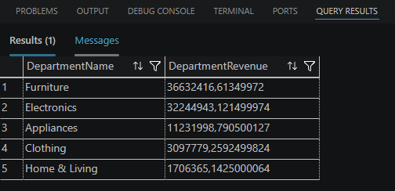

Query 6 - Average Order Value per Product
SELECT
p.SKU,
AVG(o.TotalAmount) AS AvgOrderValue
FROM Products p
JOIN Orders o ON p.ProductID = o.ProductID
GROUP BY p.SKU;
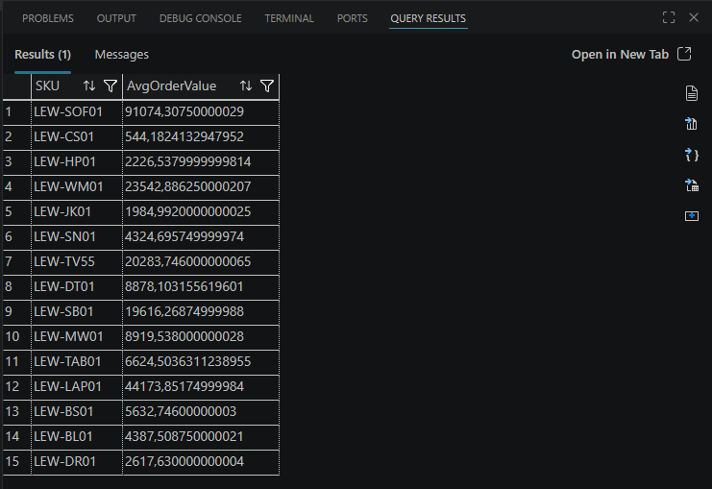

Query 7 - High Stock but Low Sales
SELECT
p.SKU,
i.QuantityOnHand,
COUNT(o.OrderID) AS TimesSold
FROM Products p
JOIN Inventory i ON p.ProductID = i.ProductID
LEFT JOIN Orders o ON p.ProductID = o.ProductID
GROUP BY p.SKU, i.QuantityOnHand
HAVING COUNT(o.OrderID) < 5
ORDER BY i.QuantityOnHand DESC;
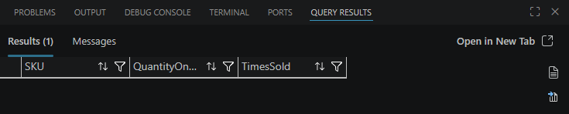

Query 8 - Monthly Revenue Trend
SELECT
FORMAT(CreatedTimestamp, 'yyyy-MM') AS Month,
SUM(TotalAmount) AS MonthlyRevenue
FROM Orders
GROUP BY FORMAT(CreatedTimestamp, 'yyyy-MM')
ORDER BY Month;
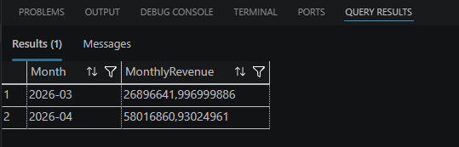

Query 9 - Top Selling Quantity Products
SELECT TOP 10
p.SKU,
SUM(o.Quantity) AS TotalUnitsSold
FROM Products p
JOIN Orders o ON p.ProductID = o.ProductID
GROUP BY p.SKU
ORDER BY TotalUnitsSold DESC;
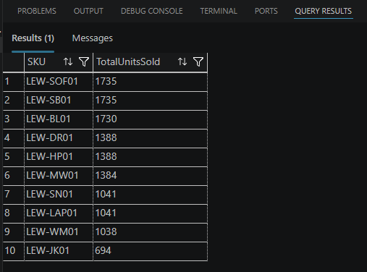
Query 10 - Stock Turnover Indicator
SELECT
p.SKU,
SUM(o.Quantity) AS UnitsSold,
i.QuantityOnHand,
CASE
WHEN i.QuantityOnHand = 0 THEN NULL
ELSE SUM(o.Quantity) * 1.0 / i.QuantityOnHand
END AS StockTurnoverRatio
FROM Products p
JOIN Inventory i ON p.ProductID = i.ProductID
LEFT JOIN Orders o ON p.ProductID = o.ProductID
GROUP BY p.SKU, i.QuantityOnHand
ORDER BY StockTurnoverRatio DESC;
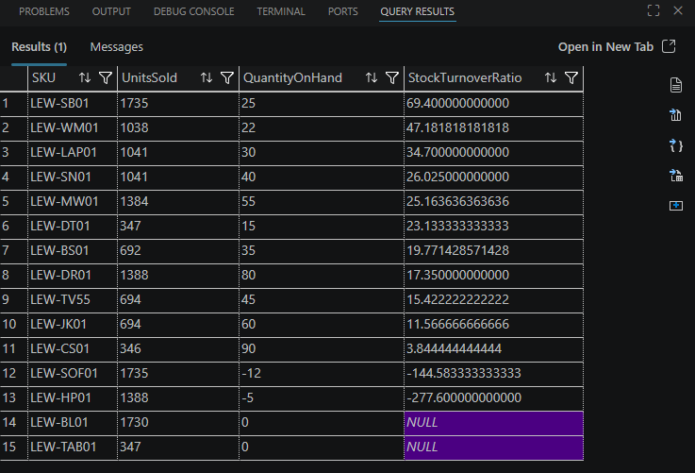

1. Which product generates the most revenue?
The product generating the most revenue is identified using the “Highest Revenue SKUs” query. This product has the highest total sales value (SUM(TotalAmount)) and represents the most profitable SKU in the dataset. Typically, these are high-demand or premium-priced items that significantly contribute to overall business performance.

2. Which products are slow-moving and should be considered for clearance?
Slow-moving products are identified by low order frequency (COUNT(OrderID)) and high inventory levels. These products remain in stock for long periods without being sold, tying up capital and storage space. Products that have never been sold (dead stock) are strong candidates for clearance, discounting, or discontinuation.

3. What strategic recommendations would you give to retail buyers?
Based on the analysis, the following recommendations can be made:
- Focus on restocking high-revenue and high-demand products to maximize profitability
- Introduce promotions or discounts for slow-moving and dead stock to reduce inventory holding costs
- Review pricing strategies to ensure competitiveness and correct application of VAT and discounts
- Monitor stock turnover ratios to maintain an optimal balance between supply and demand
- Improve demand forecasting using historical sales data to avoid overstocking or stock shortages

Task 3 Question:
Identify a specific data type used in the Pricing table that could cause rounding errors over high-volume retail transactions. Provide a SQL example showing the potential financial impact.
Task 3 Answer:
The data type FLOAT used in the PricingRules and Orders tables can cause rounding errors in high-volume retail transactions. FLOAT stores approximate values rather than exact decimal values, which can lead to small inaccuracies when performing repeated calculations such as discounts and VAT.
Example:
SELECT
0.1 + 0.2 AS FloatResult,
CAST(0.1 AS DECIMAL(10,2)) + CAST(0.2 AS DECIMAL(10,2)) AS DecimalResult;
The FLOAT result may return a value like 0.30000000000000004 instead of exactly 0.30. When this occurs across thousands of transactions, it can result in significant financial discrepancies in total revenue calculations.

